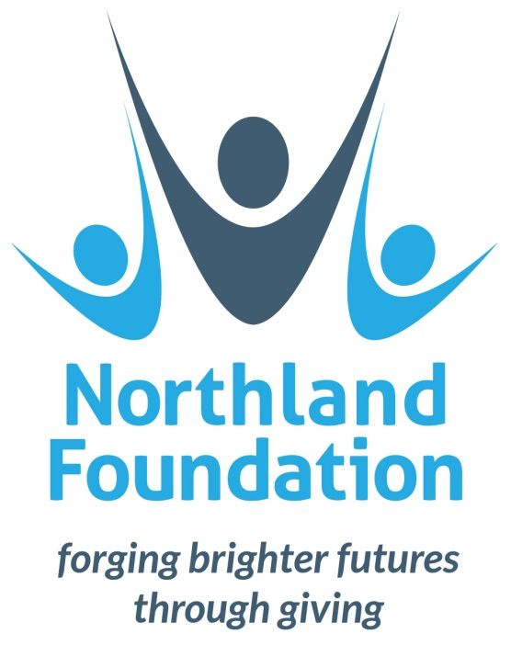

NORTHLAND
GRASSROOTS GIVING FUND 2017

APPLICATION GUIDANCE NOTES

CONTENTS

NORTHLAND GRASSROOTS GIVING FUND: ABOUT THE FUND …………………………………….. 3
ORGANISATIONS SUPPORTED …………………………………………………………………….………………… 3
FUNDING PRIORITIES ………………………………………………………………………………….………………… 3
- EARLY CHILDHOOD …………………………………………………………………………………… 3
- YOUTH DEVELOPMENT ………………………………………………………….………………….. 4
- LITERACY AND NUMERACY ………………………………………………….…………………….. 4
- BUDGETING ………………………………………………………………………………………………. 4
- MAORI ………………………………………………………………………………………………………. 5
- MIGRANT, REFUGEE AND CROSS CULTURAL …………………………..………………… 5
- HOUSING ………………………………………………………………………………….……………….. 5
HOW TO APPLY ………………………………………………………………………………………….…………………. 6
DEADLINES ………………………………………………………………………………….…………………… 6
COMPLETED APPLICATIONS …………………………………………………………….………………. 6
ENQUIRIES …………………………………………………………………………………….………………… 6
FUNDING GUIDELINES ……………………………………………………………………………….………………… 7
PRINCIPLES ……………………………………………………………………………………….…………….. 7
ELIGIBLE EXPEDITURE ……………………………………………………………………….…………….. 7
GST ……………………………………………………………………………………………….………………… 7
SIZE OF GRANTS …………………………………………………………………………….……………….. 7
PROJECT LOCATION ……………………………………………………………………….……………….. 8
EXCLUSIONS ………………………………………………………………………………….………………… 8

NORTHLAND GRASSROOTS GIVING FUND: ABOUT THE FUND

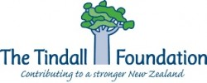
Northland Foundation (NF) is an appointed Funding Manager for The Tindall Foundation in the Northland region.

NF allocates funding under The Tindall Foundation’s programme area of ‘Supporting Families and Social Services’.

NF will be distributing this funding from our ‘Northland Grassroots Giving Fund’, in line with The Tindall Foundation’s allocation principles.

ORGANISATIONS SUPPORTED

The Northland Grassroots Giving Fund will not be awarded to individuals, but can be awarded to the following not-for-profit organisations where charitable purposes can be clearly demonstrated (through a deed or governing rules):

- Registered charities
- Incorporated societies
- Community groups or collaborations
- Schools (not for core education)

The Northland Grassroots Giving Fund prioritises small organisations with high voluntary content, rather than larger externally-funded service providers.

Social Enterprises are not eligible to apply to this fund as The Tindall Foundation supports Social Enterprises though its other funding streams.

NB: If you receive funding support through Catholic Caring funds you are unable to apply to the NCF Grassroots Fund.

FUNDING PRIORITIES

Funds are allocated to community and not-for-profit organisations for the purpose of supporting families and social services. Categories for funding are:

- EARLY CHILDHOOD

The Northland Grassroots Giving Fund will consider applications for projects that support early childhood (defined as children up to 7 years of age). Projects should provide positive experiences for children so that they have a foundation for success in later life.

Consideration will be given to projects or programmes that:
- Improve understanding of why and how we should parent and protect children.
- Increase the skills of people who bring up and work with children.
- Build the capacity of organisations that work with children.

Preference will be given to projects/programmes that are community-led, build durable skills amongst high needs groups and link-in with wider community initiatives.

- YOUTH DEVELOPMENT

The Northland Grassroots Giving Fund will consider applications for projects that support youth development and youth transitions. Projects should empower young people to make positive choices and to make positive connections with home, school, peers and community.

Consideration will be given to projects or programmes that:
- Take a positive youth development approach and are delivered by skilled people with existing connections to the target audience.
- Avoid working with young people in a way that disconnects them from their parents, whānau/family, peers or community.
- Have strong support from the community.
- Target high-needs youth.

Preference will be given to projects/programmes that include active involvement of young people at all stages, and build the capacity of young people to continue positive changes and develop youth leadership.

- LITERACY AND NUMERACY

The Northland Grassroots Giving Fund will consider applications for projects that develop adult numeracy and literacy skills. We are particularly interested in projects where the outcomes of raising literacy and numeracy skills include employability, social integration, and ultimately poverty reduction.

Consideration will be given to local groups and branches working in this area, especially those using volunteers who are trained and certified through a credible network.

Preference will be given to:
- Programmes that target groups with greater needs, such as migrants, Maori and Pacifica.
- Family literacy initiatives where parent and child learn and improve together.

- BUDGETING

The Northland Grassroots Giving Fund will consider applications for projects that support budgeting skills. Programmes should build budgeting skills to tackle the underlying lack of financial literacy that can so often cause other problems – like gambling, housing problems and poverty – to develop.

Consideration will be given to local groups/organisations that can:
- Provide free, local and quality budgeting services.
- Enhance financial literacy.
- Discourage indebtedness.

Preference will be given to organisations that work in collaboration with other providers/support services, and initiatives that use volunteers that have been trained and certified by a credible national network.

NB: If you receive funding support through Catholic Caring funds you are unable to apply to the NCF Grassroots Fund.

- MAORI

The Northland Grassroots Giving Fund recognises the tangata whenua status of Maori and will consider projects that support Maori to participate fully in society and to express their culture and unique attributes as assets for themselves, their communities and Aotearoa.

Consideration will be given to projects or programmes that:
- Provide family and social support to Maori, in line with the other priorities of the Northland Grassroots Giving Fund.
- Support and highlight positive achievement by Maori.
- Support Maori whānau and communities to find their own solutions.
- Involve Maori in design and delivery to ensure cultural appropriateness and effectiveness.

Preference will be given to projects in areas where Maori are over-represented in disadvantage statistics, and to projects that build the capacity of Maori organisations to operate effectively for their people.

- MIGRANT, REFUGEE AND CROSS CULTURAL

The Northland Grassroots Giving Fund will consider applications for projects that support migrants, refugees and people of other cultures to participate fully in society and to express their culture and unique attributes as assets for themselves, their communities and New Zealand.

Consideration will be given to projects or programmes that:
- Provide family and social support to migrants, refugees and people of other cultures, in line with the other priorities of the Northland Grassroots Giving Fund.
- Fill gaps that are not covered by local and central government provision.
- Involve migrant communities in design and delivery to ensure cultural appropriateness and effectiveness.

Preference will be given to projects that build the capacity of small voluntary groups and migrant-led organisations so that they can operate effectively for their people at a grassroots level. Collaborative projects will also be prioritised.

- HOUSING

The Northland Grassroots Giving Fund will consider applications for projects that support Northlanders to access affordable, healthy and secure housing, which is considered to be a determinant of social and economic wellbeing. Projects should target support to low-income or disadvantaged groups that struggle to access housing.

Consideration will be given to community housing or homelessness service providers for initiatives that:
- Build community self-reliance relating to housing access and security.
- Build the capacity of community housing /homelessness providers to deliver housing services and to provide access to affordable, healthy and secure housing.
- Build the capacity of community groups to engage in joint planning with Iwi, local government and community providers, so that housing supply and demand barriers can be navigated more effectively.
HOW TO APPLY

DEADLINES

June 2017 | Fund opens for applications
30 July 2017 | Deadline for full applications
September 2017 | Notification of final decision
October 2017 | Grant Payment

COMPLETED APPLICATIONS

Applications must be submitted using the form provided.

If you are unsure if you are meeting funding criteria, please submit a ‘Preliminary Application’ form to assess your eligibility. Note – full application forms must be received by 5pm 30 July 2017.

All applications will be acknowledged by email.

There are two ways to submit your application:

By E-mail

Electronic applications may be emailed to:
greta@northlandcommunityfoundation.org.nz

By Post
Hard copy applications may be returned to:

Northland Grassroots Giving Fund
Northland Foundation
PO Box 10011
Te Mai
Whangarei 0143

ENQUIRIES

Please address enquiries to Northland Community Foundation:

Greta Buchanan - Manager
Northland Community Foundation
09 470 0000 ext. 3322
greta@northlandcommunityfoundation.org.nz

FUNDING PRIORITIES

PRINCIPLES

The Northland Grassroots Giving Fund makes donations based on the shared principles of Northland Foundation and The Tindall Foundation (who provides the funds for the Northland Grassroots Giving Fund):

- Projects can be ‘bottom of the cliff’ or ‘top of the cliff’, with a preference for the latter (early intervention and prevention).
- Preference is given for small organisations or groups with high volunteer content, rather than large, well-funded applications.
- Organisations should be effective at helping the most needy, and therefore projects must have clear indicators that demonstrate how the project’s intended outcomes will be achieved.
- Preference is given for projects that are collaborative.
- Preference is given to projects that are community-led and build a community’s own capacity to lead change.
- Grants must be acceptable to the community, support community outcomes that are not readily achievable without the Foundation’s funding, add value to the community and demonstrate long-lasting value to the community.

Projects can be new and innovative but we will also consider supporting existing projects as long as the applicant can clearly demonstrate that funding would enable significantly improved effectiveness or scale.

ELIGIBLE EXPENDITURE

Applications will be considered for the following grants:

- Capital items and equipment up to a maximum of $1,500.
- Programme costs, including salaries directly applicable to programme delivery.

ELIGIBLE EXPENDITURE

The grant will not attract GST by your organisation. If you are GST registered the grant will not cover the GST component of any purchase of goods or services. Applicants are requested to exclude GST from the budget when completing the application form.

SIZE OF GRANTS

Funding requests should be between $1,000 and $15,000.

LENGTH OF GRANT AND RE-APPLICATION

Grants are provided as one-off support (1 year).

Previous recipients may re-apply to consecutive granting rounds - organisations can be supported consecutively for a maximum of 3-5 years. Funding beyond 3 years will only be considered if:

- The project or programme is demonstrating continued effectiveness with those in the community that have the greatest need.
- There are no other providers offering this project or programme and it is filling a significant gap.
- The project/programme cannot be provided with funding from other sources.

PROJECT LOCATION

Northland Foundation manages the Northland Grassroots Giving Fund as a Funding Manager for The Tindall Foundation. The funding can support projects/programmes with the Northland region only:

- Whangarei
- Kaipara
- Far North

EXCLUSIONS

Grants cannot be awarded for the following:

- Projects outside Northland
- Buildings
- Capital assets or equipment costing over $1,500
- Loan & endowment funds
- Business or investment capital
- Venture capital Initiatives
- Establishment of charities
- Individuals
- Retrospective applications (i.e. if you are seeking funding for an event or purchase that will be made before September 2017 then it will not be eligible)
- Religious or political advocacy or advancement
- Environmental projects (The Tindall Foundation supports these projects through WWF)
- Overseas travel, expenses or exchange programmes
- Drama, art or performing arts*
- Core education, scholarships and equipment or projects that deliver core education*
- Sport and recreation, sports equipment or expenses*
- Health, medical, disabilities, health equipment or expenses*

*These exclusions apply when the purpose and client group of the organisation is primarily focused on these areas. If you are unsure of your eligibility, please contact us to enquire.

